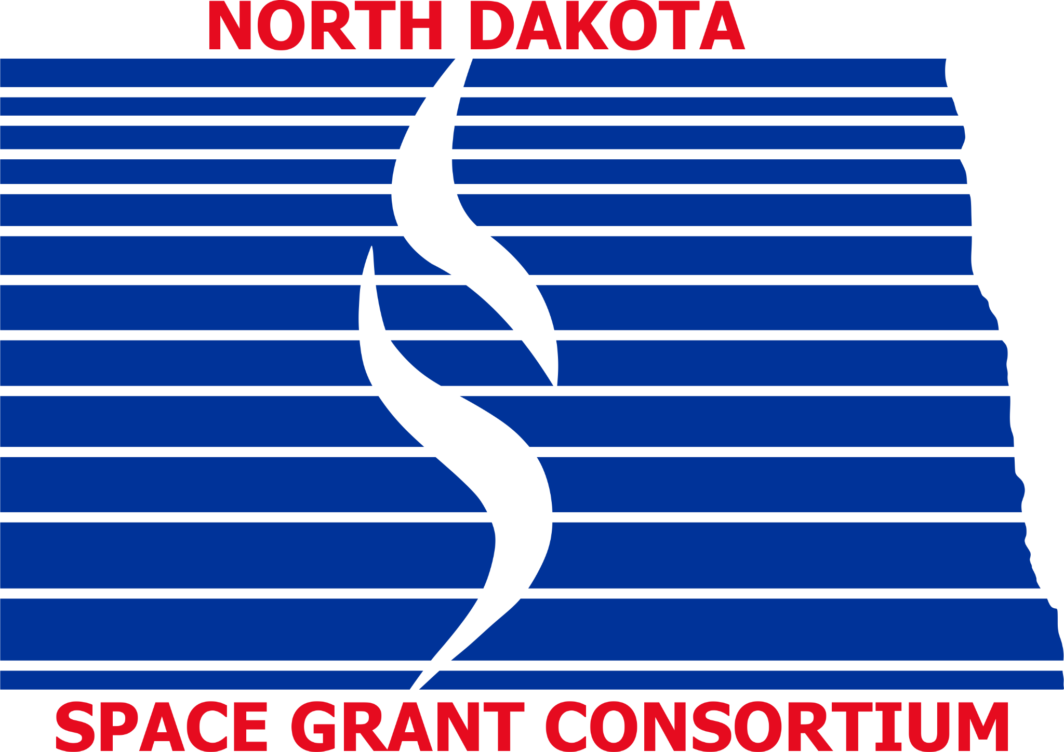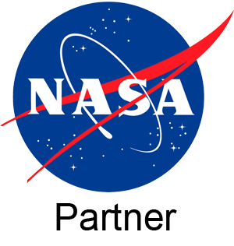
North Dakota Space Grant Consortium Scholarship Program
Goals:
- To identify, recruit, and retain students in science, technology, engineering, and mathematics
- To encourage women and underrepresented students to enter these fields of study
- To increase NASA activities and awareness in North Dakota
Eligibility:
Applicants must be citizens of the United States who are enrolled in an undergraduate program at a tribal or public two-year or four-year institution of higher education in North Dakota. The degree program should be in or related to the areas of science, technology, engineering, or mathematics.
Description of Undergraduate Scholarships:
Undergraduate scholarships will be awarded each school year and are merit based. The Office of Financial Aid and STEM departments at each college will determine the number of scholarships awarded and the due date for applications for each school year. Scholarship awards are limited to $2,500 per student. Students at UND and NDSU are not eligible for these scholarships.
Primary selection criteria are:
- Academic excellence (a minimum GPA of 3.00 is required)
- Relevance of the student’s discipline and interests to science, technology, engineering, and mathematics
Application Procedure:
Applicants should submit the following to their respective Office of Financial Aid:
- Completed application form; found below and available from your schools’ Office of Financial Aid or online at: https://ndspacegrant.und.edu/college-students/scholarships/undergraduate.html
- BSC Students will submit the following Submittable scholarship application, online: NDSGC’s BSC Undergraduate Scholarship application.
- Letter of recommendation from at least one faculty member.
*Only Lake Region State College students: Please submit a one-page essay about yourself and your current and future educational goals and how they are related to this scholarship. Deliver your documents to the LRSC Financial Aid Office or email lrsc.financialaid@lrsc.edu. Deadline is November 13th, 2023.
*Only Mayville State University students: Please submit your application and letter of recommendation to Khwaja Hossain (k.hossain@mayvillestate.edu). Deadline is November 24th, 2023.
*Only Minot State University students: Please submit your application and letter of recommendation to financialaid@minotstateu.edu. Deadline is October 31st, 2023.
*Only Bismarck State College students: The NDSGC’s BSC Undergraduate Scholarship application is found here: NDSGC’s BSC Undergraduate Scholarship application. Application will request a letter of recommendation, a resume, a transcript, and an essay response. Deadline is February 15th, 2024.
For additional information regarding the North Dakota Space Grant Consortium Scholarship Program, contact NDSGC Associate Director Tori McIntosh (tori.mcintosh@und.edu)
North Dakota Space Grant Consortium Scholarship Program
Application Form: Applicants must be citizens of the United States, have a minimum GPA of 3.00, and be pursuing a degree in a STEM field.
Name:_________________________________________________________________________
Current address:_________________________________________________________________
Hometown address:______________________________________________________________
E-mail:_________________________________ Phone:_______________________________
Student I.D. number:______________________ Undergraduate GPA:____________________
Major:______________________________ Minor:_______________________________
North Dakota institution where you are pursuing your degree:
_______________________________________________________________________________
Name of advisor:____________________ Advisor’s email:_____________________
Name of U.S. city where you were born or naturalized: ___________________________________
The following questions are optional, included for government reporting purposes only.
Date of birth: ______________________
Gender: O Male O Female O Other O Prefer not to disclose
How do you identify yourself? (Check all that apply.)
O Black or African American O Native American or Alaska Native American
O Hispanic or Latino O Multiracial American
O Asian American O White
O Middle Eastern or North African American O Native Hawaiian or Other Pacific Islanders American
O Prefer not to disclose
Disabled: O Yes O No O Prefer not to disclose

